**Experiment 2**

Name - Shikha Sanjay Choudhari

PRN- 21620010

**Title- To perform normalization of data (Min-Max and Z-score)**

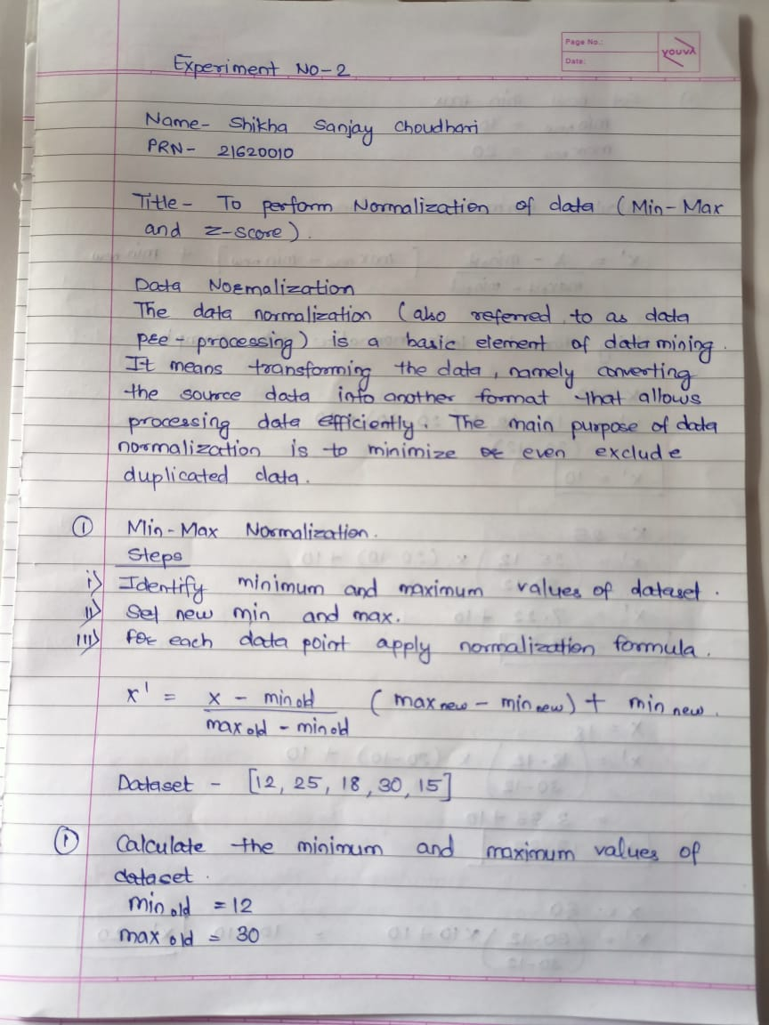

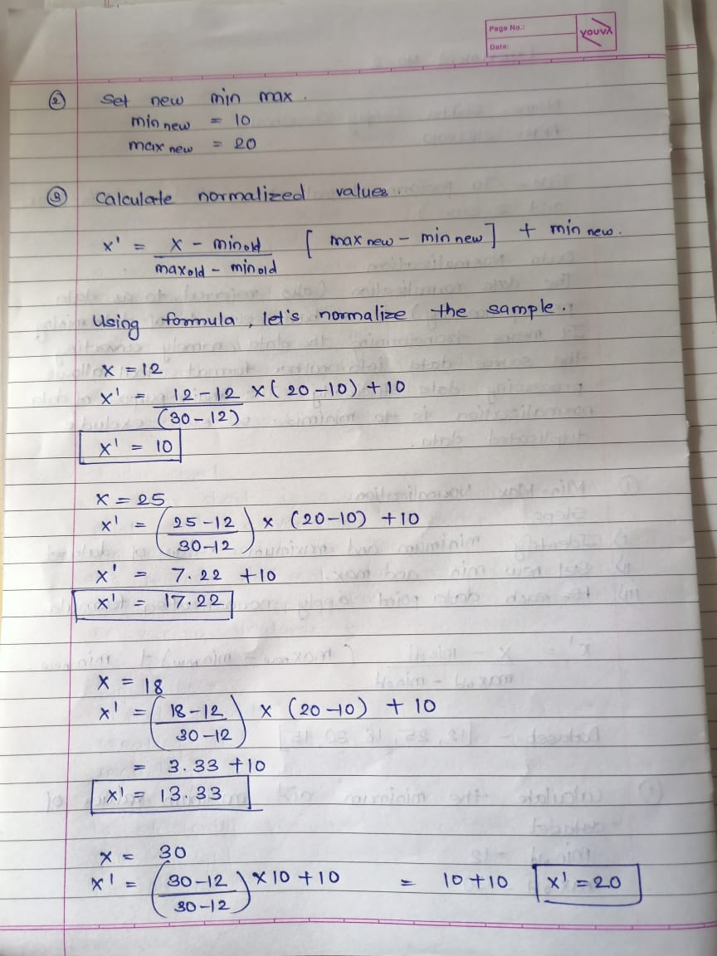

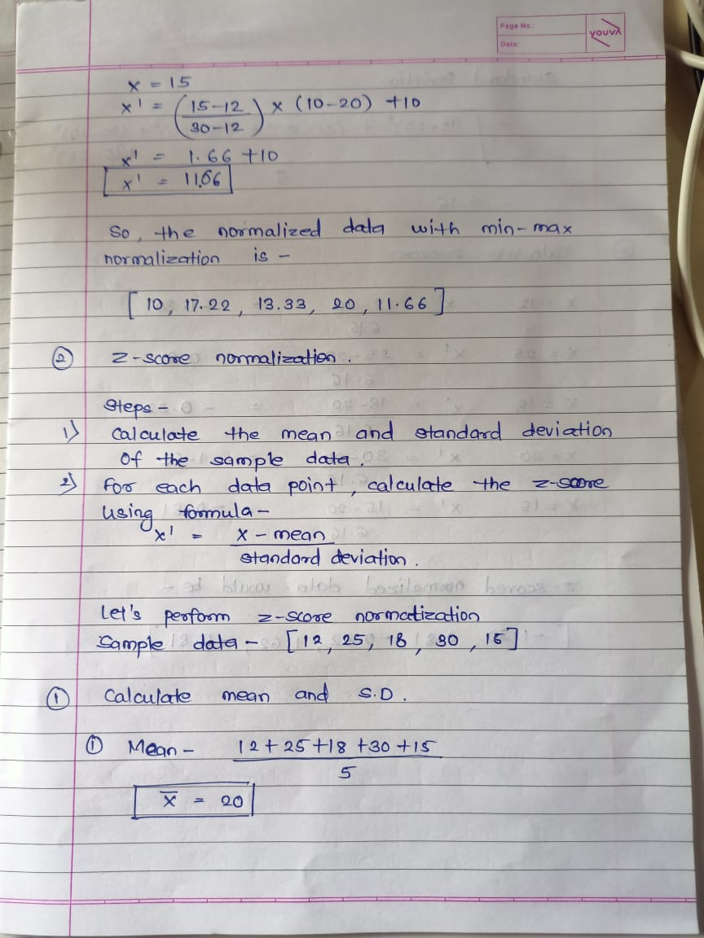

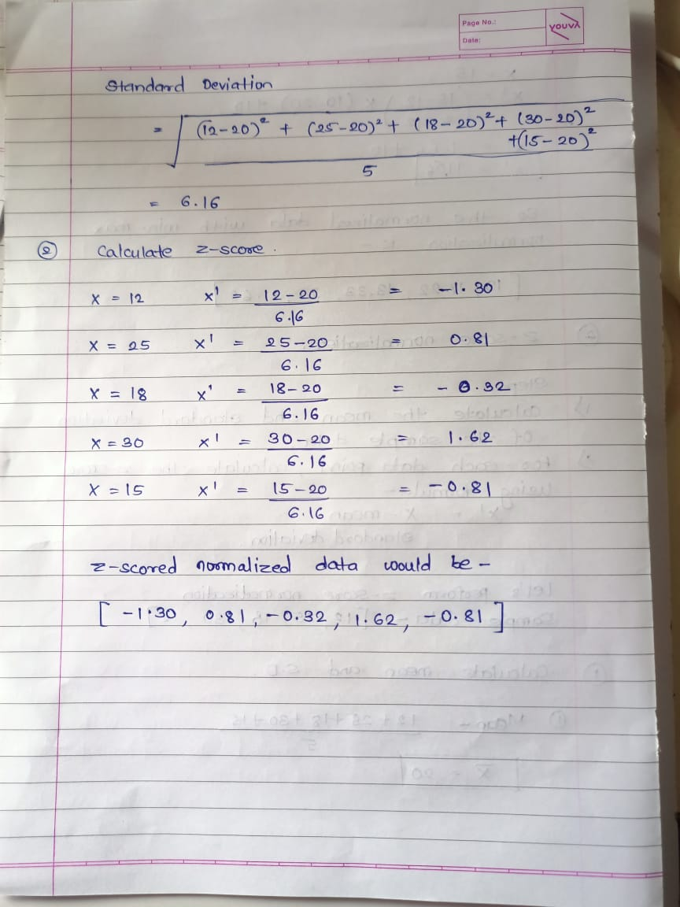

* **Code**

#include <bits/stdc++.h>

#include <fstream>

#include <vector>

#include <cmath>

#include <string>

using namespace std;

// Function to perform min-max normalization using the specified formula

vector<double> minMaxNormalization(const vector<double>& data, double min_new, double max_new) {

    double min_old = *min_element(data.begin(), data.end());

    double max_old = *max_element(data.begin(), data.end());

    vector<double> normalized_data;

    for (double val : data) {

        double normalized_val = (val - min_old) / (max_old - min_old) * (max_new - min_new) + min_new;

        normalized_data.push_back(normalized_val);

    }

    return normalized_data;

}

// Function to perform z-score normalization

vector<double> zScoreNormalization(const vector<double>& data) {

    double mean = 0;

    for (double val : data) {

        mean += val;

    }

    mean /= data.size();

    double variance = 0;

    for (double val : data) {

        variance += (val - mean) * (val - mean);

    }

    variance /= data.size();

    double std_deviation = sqrt(variance);

    vector<double> normalized_data;

    for (double val : data) {

        double z_score = (val - mean) / std_deviation;

        normalized_data.push_back(z_score);

    }

    return normalized_data;

}

int main() {

    ifstream input_file("input.txt");

    ofstream output_file("output.txt");

    vector<double> data;

    double value;

    while (input_file >> value) {

        data.push_back(value);

    }

    double min_new, max_new;

    cout << "Enter the new range for min-max normalization (min new max): ";

    cin >> min_new >> max_new;

    vector<double> min_max_normalized = minMaxNormalization(data, min_new, max_new);

    vector<double> z_score_normalized = zScoreNormalization(data);

    output_file << "Min-Max Normalized Data:\n";

    for (double val : min_max_normalized) {

        output_file << val << "\n";

    }

    output_file << "\nZ-Score Normalized Data:\n";

    for (double val : z_score_normalized) {

        output_file << val << "\n";

    }

    input_file.close();

    output_file.close();

    return 0;

}

* **Input data**

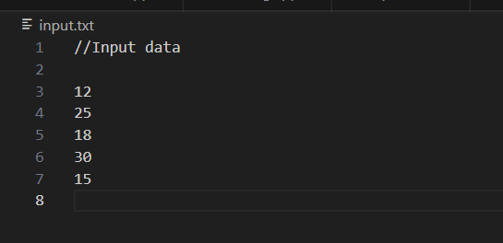

* **Output**

